Kevin Chung

9/25/19 - 9/27/19

Period 5

Journal 4

This week, I was able to make a program that segments the board given the four corners of the board. It doesn’t slice the image into bounding boxes yet, which we will need to classify the pieces later on. It only chops the board into each individual square, as shown in the image below. The board detection is still very flimsy, and I still have to tune the hyperparameters so it works on each image. An example is shown below of one image’s hyperparameters running on another image.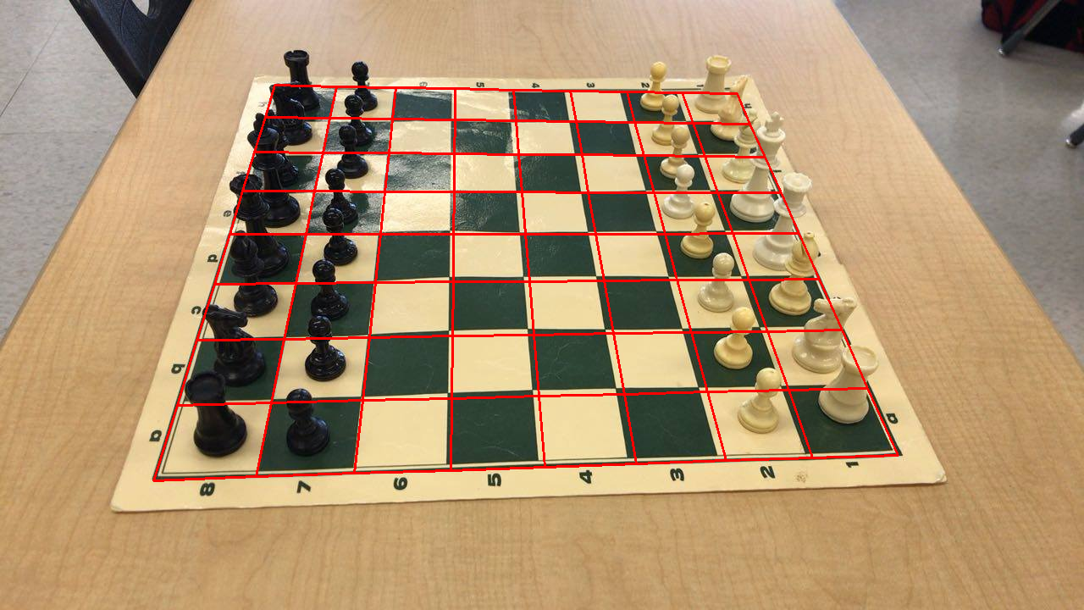

Working image:

As for next steps, I will adjust the software so it slices the image into bounding boxes, so Kevin Fu can start working on piece classification. Additionally, I will be looking at some of the papers we researched last year to improve the robustness of the board detection algorithm. I will also ask Kevin Fu to take more images so I can test the current algorithm on more test cases, as we only have a few images as of now.

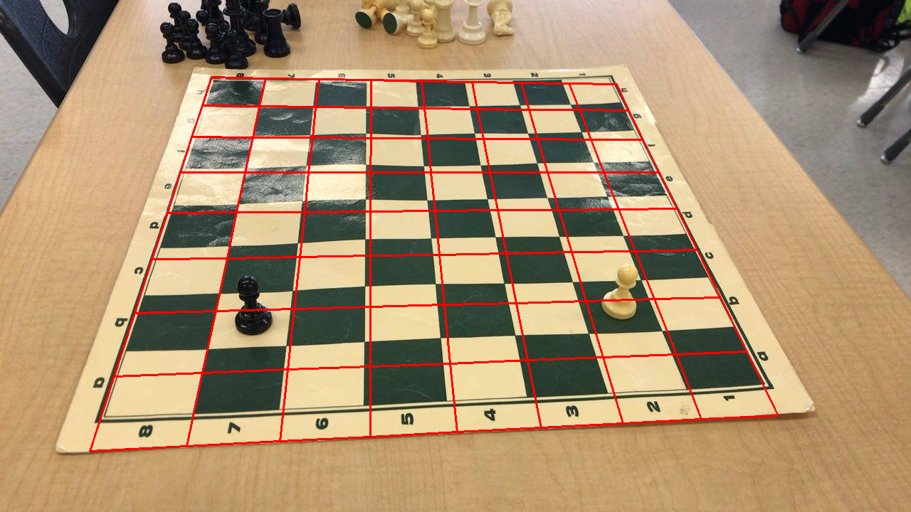

Faulty image: